Lesson 1: Graphs of Piecewise Linear Functions

Classwork

Example 1

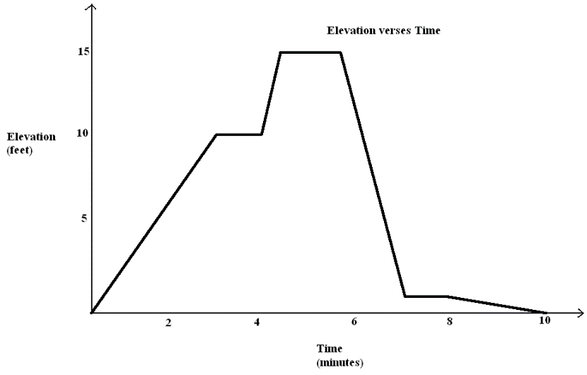Example 2

Here is an elevation-versus-time graph of a person’s motion. Can we describe what the person might have been doing?

**PIECEWISE-DEFINED LINEAR FUNCTION**: Given non-overlapping intervals on the real number line, a *(real) piecewise linear function* is a function from the union of the intervals on the real number line that is defined by (possibly different) linear functions on each interval.

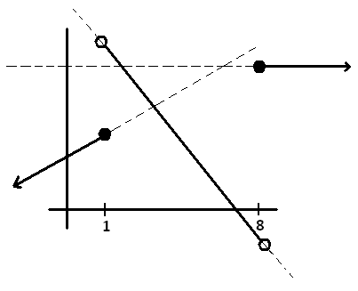

or

Problem Set

1. Watch the video, “Elevation vs. Time $3$#” (below)  
     
   <http://www.mrmeyer.com/graphingstories1/graphingstories3.mov>. (This is the third video under “Download Options” at the site <http://blog.mrmeyer.com/?p=213> called “Elevation vs. Time $3$#.”)  
     
   It shows a man climbing down a ladder that is $10$ feet high. At time $0$ seconds, his shoes are at $10$ feet above the floor, and at time $6$ seconds, his shoes are at $3$ feet. From time $6$ seconds to the $8.5$ second mark, he drinks some water on the step $3$ feet off the ground. Afterward drinking the water, he takes $1.5$ seconds to descend to the ground and then he walks into the kitchen. The video ends at the $15$ second mark.
   1. Draw your own graph for this graphing story. Use straight line segments in your graph to model the elevation of the man over different time intervals. Label your $x$-axis and $y$-axis appropriately and give a title for your graph*.*
   2. Your picture is an example of a graph of a piecewise linear function. Each linear function is defined over an interval of time, represented on the horizontal axis. List those time intervals.
   3. In your graph in part (a), what does a horizontal line segment represent in the graphing story?
   4. If you measured from the top of the man’s head instead (he is $6.2$ feet tall), how would your graph change?
   5. Suppose the ladder is descending into the basement of the apartment. The top of the ladder is at ground level ( $0$ feet) and the base at the ladder is $10$ feet below ground level. How would your graph change in observing the man following the same motion descending the ladder?

f. What is his average rate of descent between time $0$ seconds and time $6$ seconds?

What was his average rate of descent between time $8.5$ seconds and time $10$ seconds?

Over which interval does he descend faster?

Describe how your graph in part a can also be used to find the interval during which he is descending fastest.

1. Make up an elevation-versus-time graphing story for the following graph:



Name ___________________________________________________ Date____________________

Lesson 1: Graphs of Piecewise Linear Functions

Exit Ticket

The graph in Example $1$ is made by combining pieces of nine linear functions (it is a piecewise linear function).  Each linear function is defined over an interval of time, represented on the horizontal axis. List those nine time intervals.

Name ___________________________________________________ Date____________________

Lesson 1: Graphs of Piecewise Linear Functions

Exit Ticket

The graph in Example $1$ is made by combining pieces of nine linear functions (it is a piecewise linear function).  Each linear function is defined over an interval of time, represented on the horizontal axis. List those nine time intervals.